**The Tigers – Solar Cabin Project**

Elgene Menon Leo Anthony (300492604)

1. **Introduction**

The purpose of this project was to design an off-grid cabin that could meet all its own electrical needs through solar power. This theoretical cabin is placed in a real location in Wellington New Zealand.

**1.1 Design Specifications**

The cabin is 40 square meters in size and has three people living in it. The cabin contains the following basic appliances and electrical devices – 1 hot water heater, 1 refrigerator, 1 electrical stove/oven, 5 electrical lights, 1 microwave, 3 phones and 3 laptops. Three decisions greatly decreased the cabin’s energy needs. First, instead of an electrical heat pump/ air conditioner the cabin’s occupant use a wood burner to heat the cabin. Second, the cabin’s occupants do not use an electrical washing machine or dryer instead they use a laundromat to do their laundry. Thirdly, the wood burner has an attachment that allows it to heat the hot water cylinder allowing the cylinder to heat water without electricity if the wood burner is being used. The project requires estimating the energy use of the cabin on the summer solstice and the winter solstice. The project also requires an estimation of the amount of available sunlight on those two days and an estimation of how much of that sunlight our solar panel system can capture. In addition, the project requires a design of our solar panel system and an estimation of its cost to build.

* 1. **Cabin Location and Design**

The cabin is located at 3898782, Point Howard, Lower Hutt 5013. The land itself is currently empty and is located on Marine Drive. The latitude of site is -41.252859 and the longitude is 174.90347080000004. The site is hilly and sits directly across the road from Wellington Harbour. The cabin is oriented on the site so that the side of the roof on which the solar panels are placed faces to the North.

The cabin itself has four rooms – a bathroom, a large living/kitchen area and two bedrooms. It has an open gable roof with the solar panels placed on the north facing side of the roof.

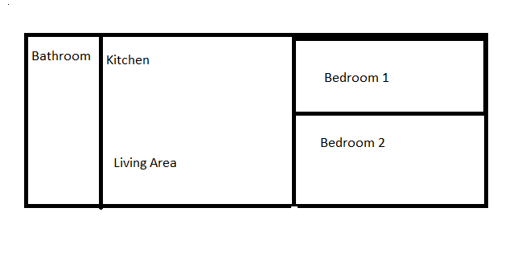

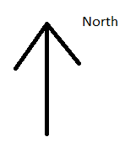

**Figure 1: Cabin Floor Plan**

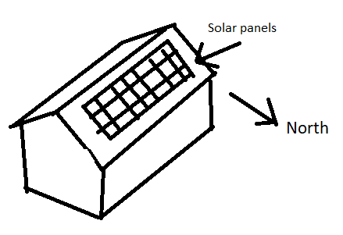

**Figure 2: Cabin three-dimensional image and orientation**

1. **Solar Resource Analysis**

The average sunshine for Winter Solstice (June 21) is 1.92 kW-hr/m2. The average sunshine for Summer Solstice (December 21) is 5.30 kW-hr/m2.

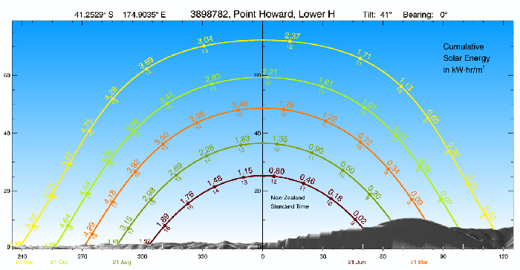

**Figure 3: Year long graph of solar energy use throughout the day**

(Source: National Institute of Water and Atmospheric Research. (2019). Solar View. Retrieved from: https://solarview.niwa.co.nz/solar_images/original/fb895ab3c81db5ad870e089a288aadd6_o.png).[1]

1. **Cabin Power and Energy Load Characterization**

The total energy use on Summer Solstice is 9.44kwhr and the power is 8.39kw. The energy use on Winter Solstice is 8.85kwhr and the power is 6.585kw. To arrive at these figures the following assumptions were made about summer and winter use of electricity.

For the Refrigerator we estimated that it would be turned on 6 hours per day. The reason that it is not turned on 24 hours a day is because refrigerators only turn on when the door is open. Otherwise they are off. Another important assumption is that the refrigerator will be used the same amount whether in summer or winter time. The manufacturers specifications state this refrigerator uses 206 kW annually. Therefore, we divided this number by 365 days to get the daily power consumption.

The hot water cylinder is a 325-litre solar storage unit with electric boost. In summertime we assume that our hot water is heated by its own solar power system. If this is not enough then it is uses electricity from the main cabin solar power system to heat the water using the electric boost function. In wintertime there may not be enough sunlight to heat the cylinder’s own solar power system. Normally we would use the electric boost function to overcome this problem using electricity from the cabin’s main solar power system. However, in winter there is less sunlight to heat the cabin’s own solar power system. Therefore, the wood burner that is used to heat the house can also be used to heat the hot water cylinder.

In addition, the cabin’s occupants only use hot water to take showers. Dishes are done in cold water using cleaning chemicals to disinfect dishes rather than hot water. Occupants of the house can take two showers of 5 minutes per day in summertime and in wintertime. In summertime our water heater uses 3.6 kW. In wintertime it only uses a quarter of that amount which is 0.9 kW. This is because in wintertime our cabin is using the wood burner to heat the water. This cannot be done in summertime because the wood burner also heats the cabin and in summertime its occupants presumably do not want it to be any warmer.

The electric stove/oven uses 2 kW for four elements according to the manufacturer’s specifications. Our occupants only cook a moderate amount and only eat one hot meal per day. Therefore, they use two elements for one hour per day in summer and winter. This works out to 1kWhr per day to use the electric stove/oven.

The cabin has five electrical lights. One in the bathroom, one in each bedroom and two in the open concept kitchen/living area. The occupants only use lights when there is no natural sunlight. The occupants also go to bed quite early in the evenings. In the summertime the occupants use the lights for two hours and for four hours in the wintertime. They use the lights more in winter because winter days have fewer sunlight hours than summertime.

The microwave is not used that often. Only thirty minutes per day in winter and summer. The occupants do not use it to cook food. They only use it to reheat leftovers and make hot drinks. They use a microwave for hot drinks rather than a kettle to reduce their overall electrical consumption.

The occupants each have a mobile phone and a laptop. They all have the same models of each item. They have been given six hours to charge their laptops and four hours to charge their phones. This is the same in summer and winter. This amount of charging time is enough to fully charge their devices even assuming their devices are being used the rest of the day. They also have a generous allowance of charging time as this is their only form of electric entertainment as they do not have a television or gaming system.

|  |  |  |  |  |  |  |
| --- | --- | --- | --- | --- | --- | --- |
| **AC Load Description** | **Brand/Model** | **Quantity** | **Cost** | **Power Rating(kW)** | **Time on per day(h/day)** | **Energy used (kwhr)** |
| Refrigerator | Gram KS 3135-90[2] | 1 | $745 | 206kW/365  = 0.56kW | 6hrs | 3.36kwhr |
| Hot water cylinder | 325L Solar Storage with Electric Boost[3] | 1 | $2292 | 3.6kW | 5mins * 2 showers a day *3 people= 0.5 hr | 1.8kwhr |
| Electric Stove/oven | Westinghouse 60cm 'Mercury' Freestanding Oven[4] | 1 | $1261 | 1kW for 2 burner elements | 1hrs | 1kwhr |
| Light | Standard Reflector Bulb R95 [5] | 5 | $11.50  (one)  5x 11.50=  $57.50 | 0.075kW (One)  5x0.075= 0.38kW | 2 hrs | 0.76kwhr |
| Microwave | Samsung 28L Sensor Cook Microwave oven - ME6104ST1[6] | 1 | $249.00 | 1.5kw | 0.5 hr | 0.75kwhr |
| Laptops | HP Spectre 13-AF038TU Laptop[7] | 3 | $2405 | 0.065kW *3=  0.195kw | 6 hrs | 1.17kwhr |
| Phone | OPPO AX7 Smartphone Glaring Gold[8] | 3 | $349 | 0.05kW*3=  0.15kw | 4hrs | 0.6kwhr |
|  |  |  |  | **Total power used:**  **8.39kw** |  | **Total energy used:**  **9.44kwhr** |

**Figure 4: Maximum power and energy load characterisation in Summer**

|  |  |  |  |  |  |  |
| --- | --- | --- | --- | --- | --- | --- |
| **AC Load Description** | **Brand/Model** | **Quantity** | **Cost** | **Power Rating(W)** | **Time on per day(h/day)** | **Energy used (kwhr)** |
| Refrigerator | Gram KS 3135-90 | 1 | $745 | 206kw/365  = 0.56kW | 6hrs | 3.36kwhr |
| Hot water cylinder booster + wood burner | 325L Solar Storage with Electric Boost | 1 | $2292 | 3.6kw/4=  0.9kw | 5mins * 2 showers a day *3 people= 0.5hr | 0.45kwhr |
| Electric Stove/oven | Westinghouse 60cm 'Mercury' Freestanding Oven | 1 | $1261 | 1kw for 2 burner elements | 1hrs | 1kwhr |
| Light | Standard Reflector Bulb R95 | 5 | $11.50  (one)  5x 11.50=  $57.50 | 0.075kW (One)  5x0.075= 0.38kW | 4 hrs | 1.52kwhr |
| Microwave | Samsung 28L Sensor Cook Microwave oven - ME6104ST1 | 1 | $249.00 | 1.5kw | 0.5 hr | 0.75kwhr |
| Laptops | HP Spectre 13-AF038TU Laptop | 3 | $2405 | 0.065kW *3=  0.195kw | 6 hrs | 1.17kwhr |
| Phone | OPPO AX7 Smartphone Glaring Gold | 3 | $349 | 0.05kW*3=  0.15kw | 4hrs | 0.6kwhr |
|  |  |  |  | **Total power used:**  **6.585kw** |  | **Total energy used:**  **8.85kwhr** |

**Figure 5: Maximum power and energy load characterisation in Winter**

1. **Specification of the suggested solar PV/battery system**

**4.1 Modelling of the System**

To calculate the area of the solar panels needed to power the cabin we used the following equation: Total energy of loads/energy of sunlight area * efficiency of solar panels. The efficiency is 20%.

The equation is the same for winter and summer. However, the amount of total of energy of loads changes depending on the season. The total energy of loads is more in summertime than in wintertime for our cabin. As explained above in section 3 this is because in wintertime our cabin can use its wood burner to heat the water which significantly decreases the amount of energy used in the cabin.

The energy of sunlight area also changes. The Solar View web tool shows that the energy of sunlight area is higher in summer and lower in winter.

Therefore, the area of solar panels needed to power the cabin in summer is 9.17 m2 and when the safety margin of 10% is added the final figure is 9.80 m2. The area of solar panels needed to power the cabin in winter is 23.05 m2 and when the safety margin of 10% is added the final figure is 25.35 m2. Therefore, the total area of solar panels required for the cabin is 32.22 m2 and when the 10% safety margin is added to this the final figure is 35.15 m2. We have rounded this up to 36 m2.

The battery size required for the cabin for one day is 9.44kWhr. This figure comes from the maximum energy usage day for the cabin which occurs in summertime.

* 1. **Components and Costs**

The components we used for the cabin’s solar power system and their costs are as follows:

For the solar panels themselves we used LG315N1C-G4 monocrystalline silicon cell panels. These solar panels cost $299.00 per unit.[9] We estimate we need 36 solar panels. Therefore, the total cost of our solar panels is $10,764.

For the charge controller we used a 12V/24V 30A MPPT Solar Charge Controller. This costs $289.00.[10]

For our batteries we used VMAX SLR200 Group 4D 2.66kWh 12V 200AH AGM Deep Cycle 12 Volt Battery.[11] As each battery holds only 2.66kWh and our system needs 9.44kWh on its most energy intensive day this means we need 4 of these batteries. Each battery costs $470 so our total battery cost is $1880.

Our inverter is a MI5260 Jaycar 1500W Pure Sine Wave Inverter/Charger. This costs $1125.00.[12]

Our labour costs are $10000 and our minor supplies cost $2000.

Therefore, the total cost of our system is $26,058.

1. **Uncertainties and Contingencies**

There are several things that could make living in our cabin with its current solar power system untenable. First, as the cabin has no laundry facilities it must be located near to a laundromat. This is no problem for our cabin as it is in Lower Hutt. However, it would not suit full time rural use unless extra solar power capacity was added for at least a washing machine and perhaps a dryer.

In addition, our occupants rely on using a wood burner to heat the cabin and to significantly reduce power consumption in wintertime as they also use the wood burner to heat the hot water cylinder. This means that our occupants must have access to a large amount of wood. This means our cabin and its solar power system would not work well if wood were to become prohibitively expensive or physically unavailable.

Finally, our cabin only supplies its own electricity if the three occupants follow a strict low electricity lifestyle. This is fine as we presume our occupants are living in this manner because they are either cost or eco conscious. However, it leaves little surplus power for an emergency. This could be a natural event like a hurricane forcing the occupants to stay inside for longer than usual and use more electricity to heat and light the home or even a special occasion such as a large garden party. Therefore, even though the occupants do not need extra solar capacity for their everyday lifestyle it could be wise to build in extra capacity for emergencies or special events.

1. **Conclusions and Recommendations**

The cabin is relatively low cost as is the solar power system installed to power it. However, it only works for occupants that are committed to a low electricity use lifestyle. For example, living in our cabin requires taking short showers and only using electric lights for a short period at night. There are many people who would find this lifestyle appealing as it is low cost and has a low environmental impact. However most New Zealanders use far more electricity than this and would therefore struggle to live in our cabin. Therefore, our cabin is a great housing solution for the money or eco conscious consumer but not for the average person.

1. **References**

   National Institute of Water and Atmospheric Research. (2019). Solar View. Retrieved from: https://solarview.niwa.co.nz/solar_images/original/fb895ab3c81db5ad870e089a288aadd6_o.png
2. Low Energy Refrigeration. (2019). Gram KS. Retrieved from: http://www.lowenergyrefrigeration.co.nz/ks3135-90---135-lt-white.html
3. Plumbing Plus. (2019). Rheem 3251. Retrieved from: https://plumbingplus.co.nz/products/rheem-325l-solar-storage-with-electric-boost/?gclid=CjwKCAjwpuXpBRAAEiwAyRRPgaXlSHxe7jgwcNjq95HF7BjYIvdzx1hzKWQHaq1szqiGCHriO_H06xoCuEsQAvD_BwE
4. Harvey Norman. (2019). Westinghouse Mercury Oven. Retrieved from: https://www.harveynorman.co.nz/whiteware/kitchen/freestanding-ovens/westinghouse-60cm-mercury-freestanding-oven.html
5. Energywise. (2019). Standard Reflector Bulb R95. Retrieved from: https://www.energywise.govt.nz/tools/lighting/?gclid=EAIaIQobChMI-83jsZ3m4wIVjYRwCh3VOwJUEAAYASAAEgKC5_D_BwE
6. Smith City. (2019). Samsung 281 Microwave Oven. Retrieved from: https://www.smithscity.co.nz/whiteware/cooking/microwaves/samsung-28l-sensor-cook-microwave-oven-me6104st1-8774960?gclid=CjwKCAjwscDpBRBnEiwAnQ0HQG5s4aUhzbKUdVbpXNwAd-nAFrnrqVI4nZf_VqfXpslxFcqSNEBlxxoC2oUQAvD_BwE
7. Harvey Norman. (2019). HP Spectre Laptop. Retrieved from: https://www.harveynorman.co.nz/computers/laptops/hp-spectre-13-af038tu-laptop.html?gclid=EAIaIQobChMIsrKHiKDm4wIVjIRwCh1YEATqEAQYAyABEgLNGfD_BwE
8. Noel Leeming. (2019). Oppo Ax 7. Retrieved from: https://www.noelleeming.co.nz/shop/phones-and-gps/mobile-phones/oppo-ax7-smartphone-glaring-gold/prod171394.html?&nst=SEM&gclid=EAIaIQobChMIzIik96Xm4wIVRAwrCh060gG3EAQYCCABEgIemPD_BwE&gclsrc=aw.ds
9. Mr. Positive. (2019). 12v 120w Monocrystalline Solar Panel. Retrieved from: https://www.mrpositive.co.nz/12v-120w-monocrystalline-solar-panel
10. Jaycar. (2019). 12V/24V 30A MPPT Solar Charge Controller. Retrieved from: https://www.jaycar.co.nz/12v-24v-30a-mppt-solar-charge-controller/p/MP3735
11. Amazon. (2019). VMAX SLR2000. Retrieved from: https://www.amazon.com/VMAX-SLR200-2-66kWh-Battery-Solar/dp/B0755BSSFX.
12. Jaycar. (2019). Sine Wave Inverter Charger Retrieved from: https://www.jaycar.co.nz/1500w-pure-sine-wave-inverter-charger/p/MI5260.